* Select ‘connect to crm’ from the settings dropdown menu

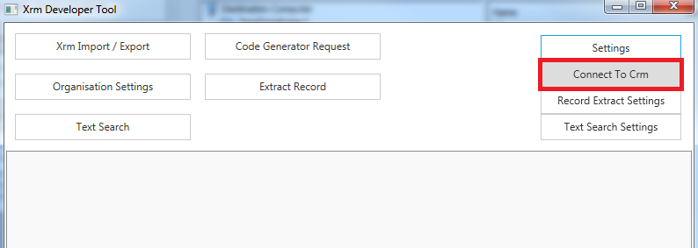

* Enter the authentication provider type\*, details for the crm instance\* and credentials of the crm user

\*if the crm instance is ifd specify federation

\*how to access the discovery service address and organization unique name is shown in a subsequent screenshot

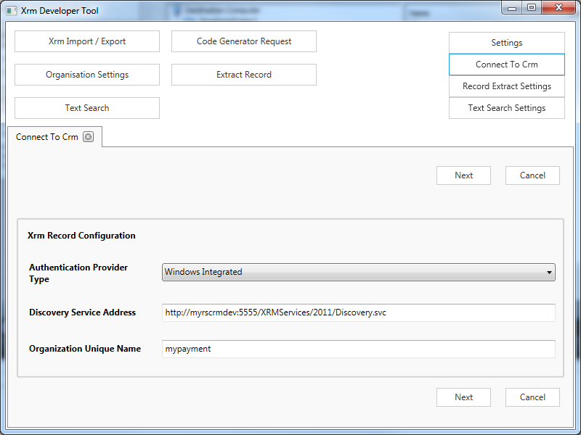

The discovery service address and organization unique name are accessible in crm by navigating to settings -> customizations -> developer resources

